Assignment 1

Oct 10,2020

1

Prepared by

Tresa Varghese

A01228545

This document is for educational/informational purposes only. The information represents the product at the time this document was printed and should be used for information purposes only. Information is subject to change at any time without prior notice. No warranties, expressed or implied, are made in this document.

Table of Contents
1 Executive Summary 1
2 Introduction 2
2.1 Purpose 2
2.2 Criteria for Completion 2
2.3 Audience 2
2.4 Background 2
3 Requirements/Pre-requisites 3
4 Environment 4
4.1 System Configuration 4
4.2 Software used 4
4.3 Accounts 4
5 Installation/Configuration Steps 5
6 Additional Notes 9
7 Conclusion 10
8 References 11

- Executive Summary
This document describes the work done as a part of Assignment 1 as a part of the completion of course COMP 4678– MS SQL Server 2016 Development.
- Introduction
  - Purpose
Contains answers to various questions included as a part of Assignment 1. It include SSMS installation, creation of database and tables and answers to queries as outlined in the assignment
  - Criteria for Completion
Completion of all the question
  - Audience
Course Instructor
  - Background
Requires installation of SQL Server and management studio.
- Requirements/Pre-requisites

- The machine used should have windows 8 or higher OS, x64 1.4GHz (Pentium IV) or higher processor, memory capacity of 1GB or more, 1.4GB disk space for installation and enough memory for database duplication.
- Download and install MS SQL Server 2016 Developer Edition successfully in the computer.
- Download and install MS SQL Server Management Studio successfully in the computer.

- Environment
  - System Configuration
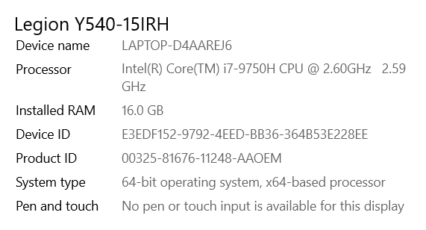
  - Software used
Software | Version
SQL Server Management Studio | 15.0.18338.0
SQL Server Management Objects (SMO) | 16.100.41011.9
Microsoft Analysis Services Client Tools | 15.0.19205.0
Microsoft Data Access Components (MDAC) | 10.0.18362.1
Microsoft MSXML | 3.0 6.0
Microsoft .NET Framework | 4.0.30319.42000
Operating System | 10.0.18363
  - Accounts
Not applicable

- Installation/Configuration Steps
Step | Server or Instance | Description | Screenshot/Notes
1 | SQL Server | Run the SQL Server 2016 Developer edition installation file | 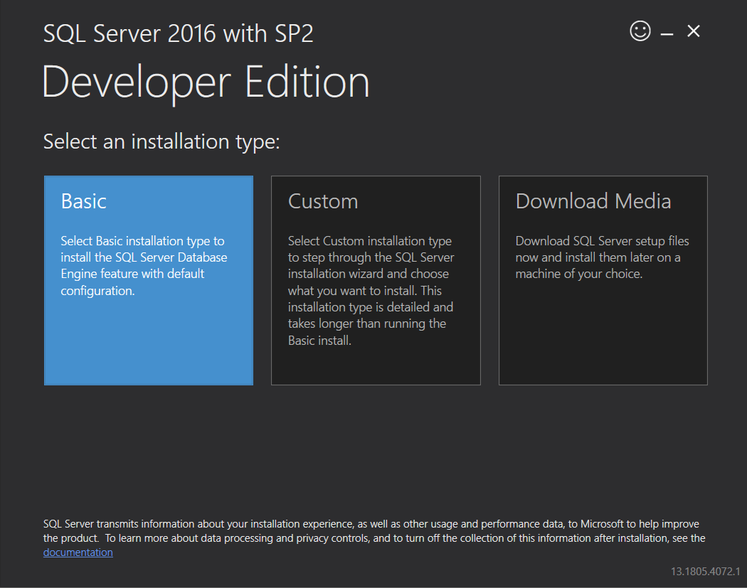
2 | MSSQLSERVER | Screenshot after successful installation of SQL Server Developer Edition | 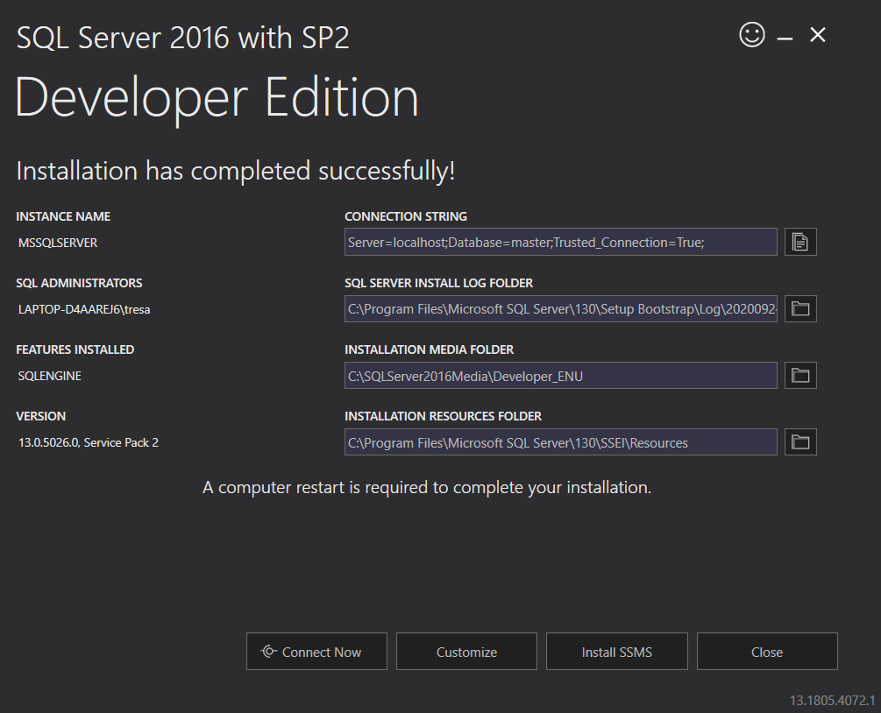
 | MS SQL Server Management Studio | Specify the location of installation of SSMS and click install | 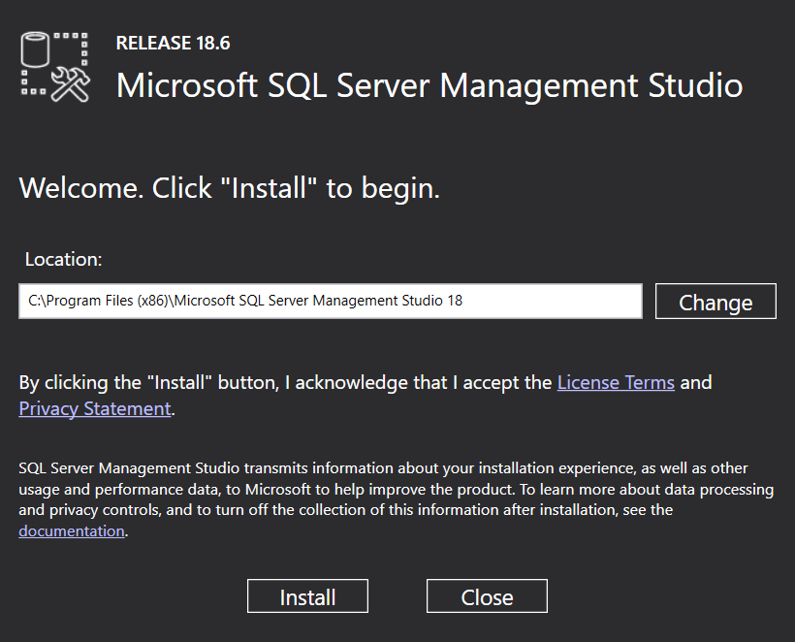
3 | MSSQLSERVER | Create new project called COMP4678_A1 | 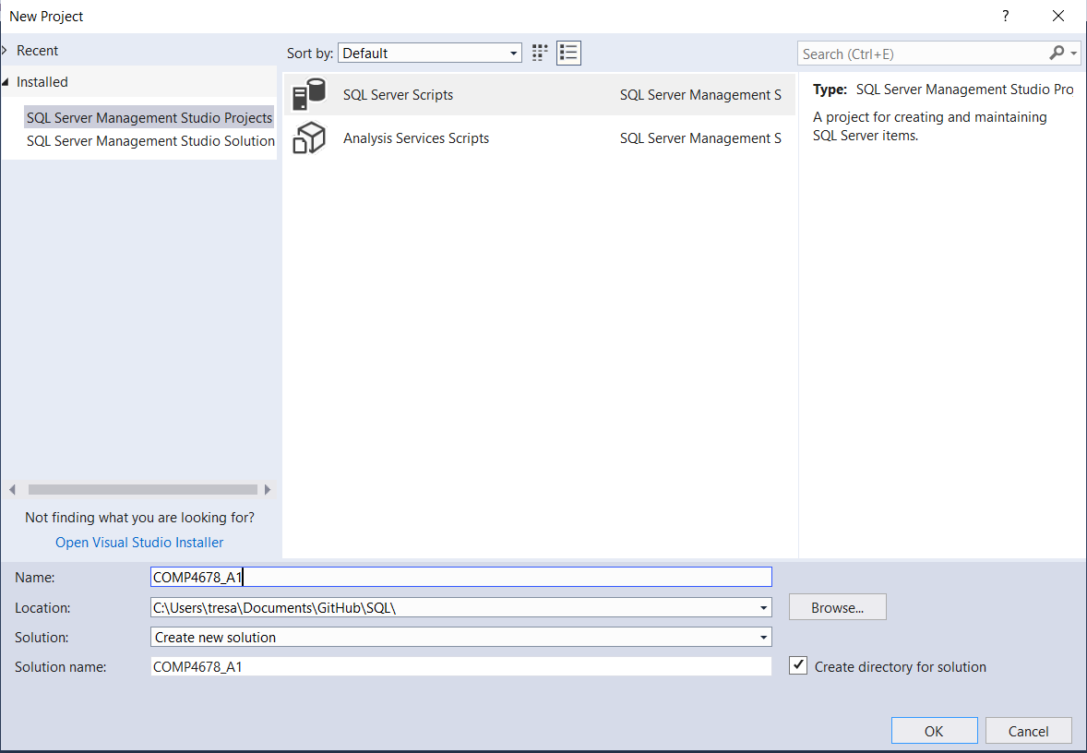
4 |  | Create server connection | 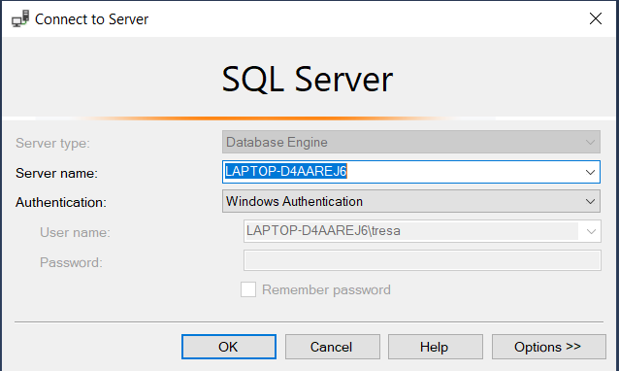
5 |  | Create new database called A1_Data | 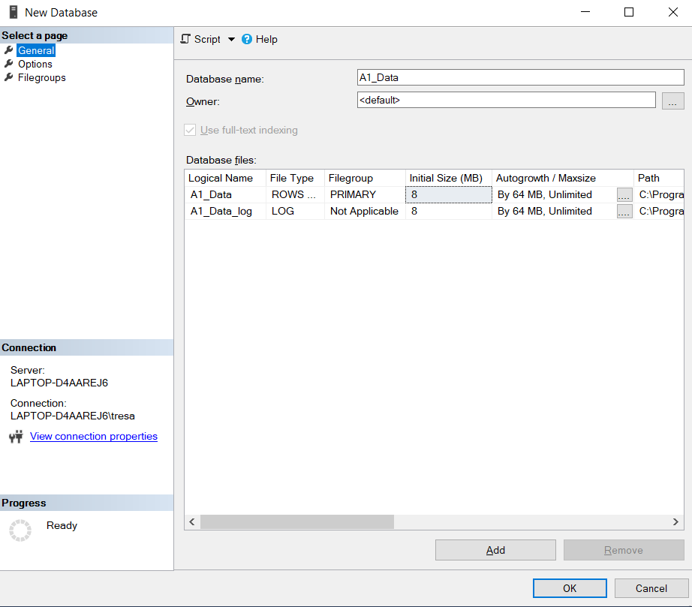
6 |  | Create tbl_Products using GUI | 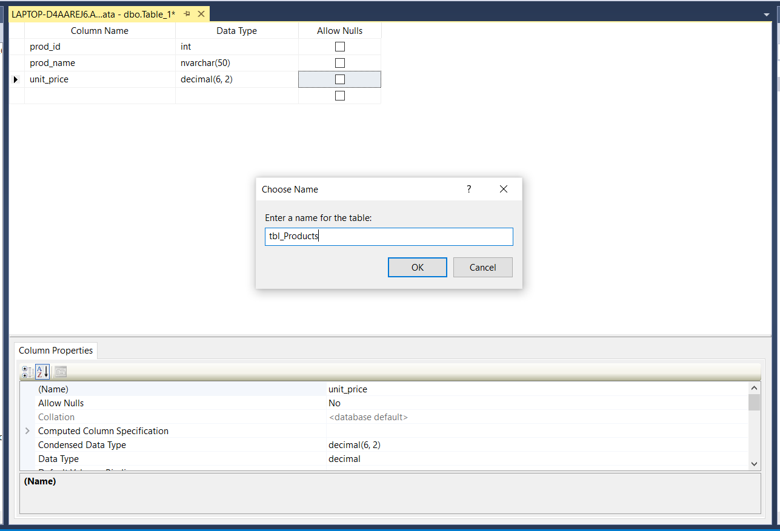
7 |  | Create tbl_Customers using GUI and generate script | 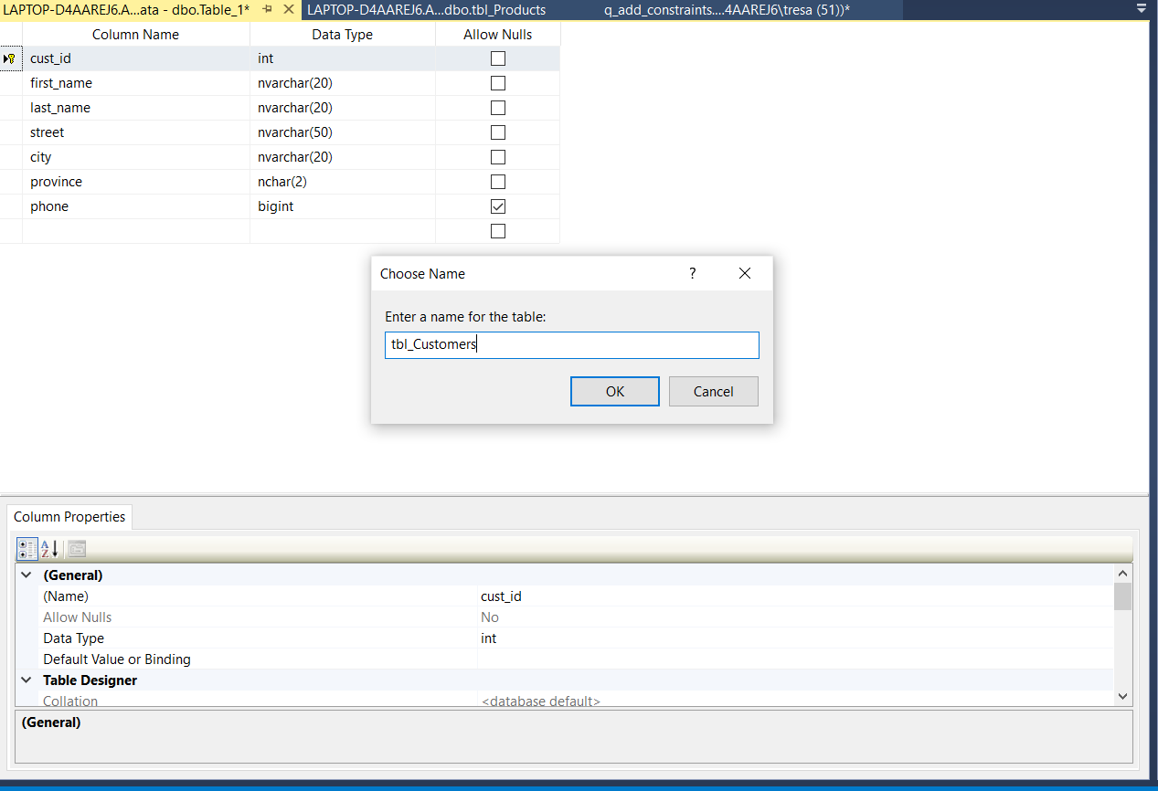
7 |  | Create tbl_Customers using GUI and generate script | 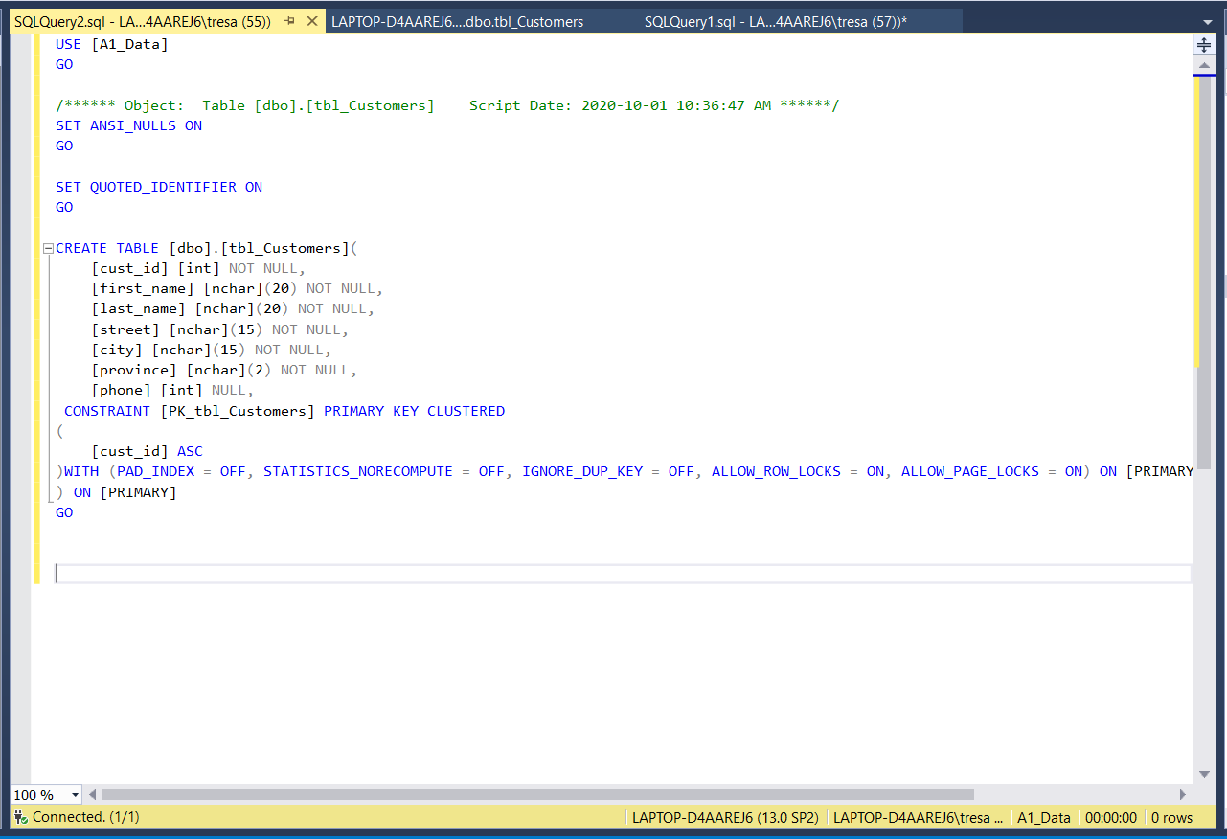
8 |  | Populate data in tables | 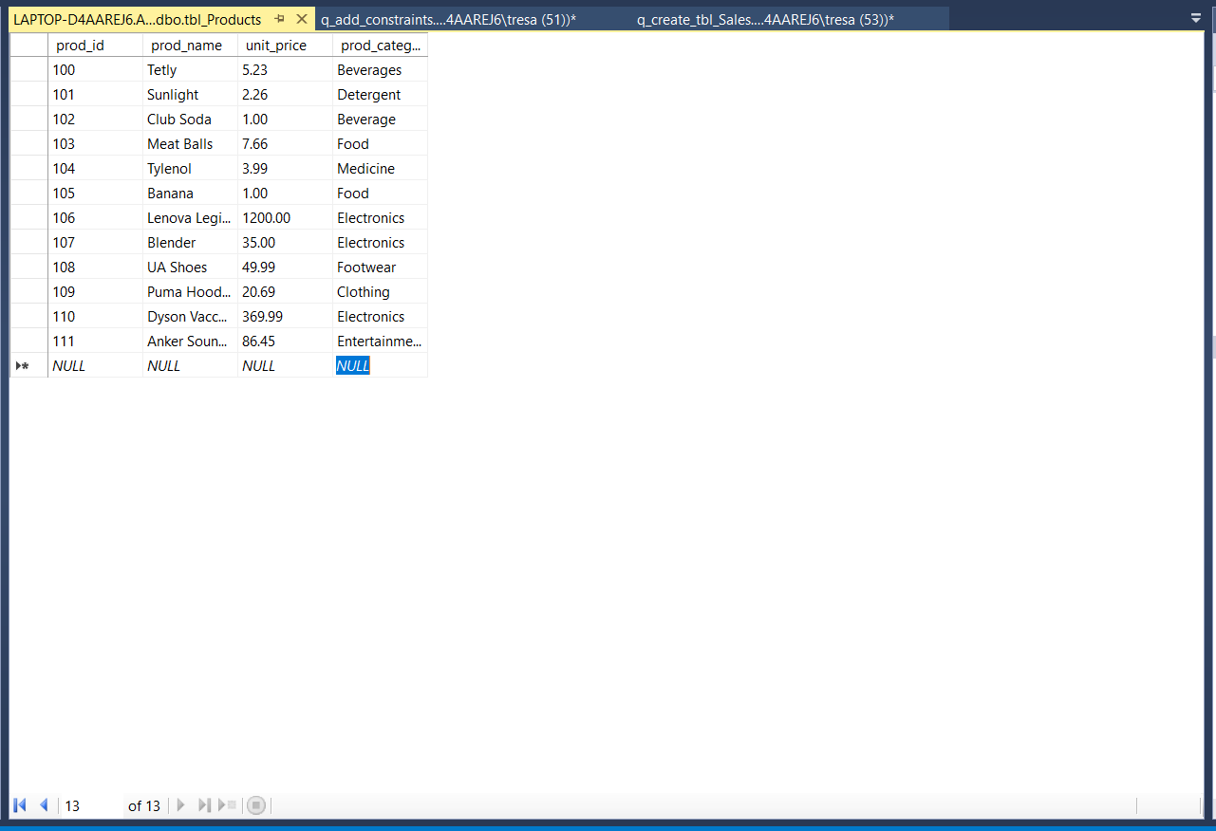

- Additional Notes
<if applicable>
- Answers to Questions

List all records in original order

USE [A1_Data]
GO

SELECT prod_id,prod_name,unit_price,prod_category
FROM tbl_Products;

SELECT transaction_id, transaction_date,prod_id,invoice_number,quantity,amount
FROM tbl_Sales;

SELECT cust_id, first_name,last_name,street,city, province, phone
FROM TBL_Customers;

List all customers from Vancouver

USE [A1_Data]
GO

SELECT CustomerName = first_name + ' ' + last_name, city
FROM tbl_Customers
WHERE city = 'Vancouver';

List all products with name starting with letter “B”

USE [A1_Data]
GO

SELECT prod_name
FROM tbl_Products
WHERE prod_name LIKE 'B%';

List 10 invoices with the highest amount

USE [A1_Data]
GO

SELECT TOP(10) invoice_number, InvoiceAmount = SUM(amount)
FROM tbl_Sales
GROUP BY invoice_number, transaction_date
ORDER BY InvoiceAmount DESC;

List 5 most recent invoices

USE [A1_Data]
GO

SELECT TOP(5) invoice_number, transaction_date, InvoiceAmount = SUM(amount)
FROM tbl_Sales
GROUP BY invoice_number,transaction_date
ORDER BY transaction_date DESC;

List number of customers in each city

USE [A1_Data]
GO

SELECT city, 'Number of Customers' = COUNT(*)
FROM tbl_Customers
GROUP BY city;

- References
Reference Title | URL (if applicable)
Date data type format and specification | https://docs.microsoft.com/en-us/sql/t-sql/functions/date-and-time-data-types-and-functions-transact-sql?view=sql-server-ver15
TOP(n) documentation | https://docs.microsoft.com/en-us/sql/t-sql/queries/top-transact-sql?view=sql-server-ver15

